Almely Ramos

Tmux Documentation

Linux Admin

10/7/19

(YOU MUST BE ROOT or USE SUDO)

Step 1: Enter sudo yum makecache into you the command line to make sure “yum” installer is up to date.

**Step 2: Enter sudo yum install tmux -y (THIIS WILL INSTALL TMUX) hit enter.**

Let it download, hit yes if prompted to and after that you should be good to use Tmux.

**Using Tmux**

**Starting up:**

To start up tmux, all you must do is enter “tmux” on the command line.

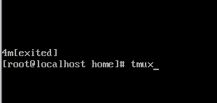

Heres how you know you’ve entered tmux correctly:

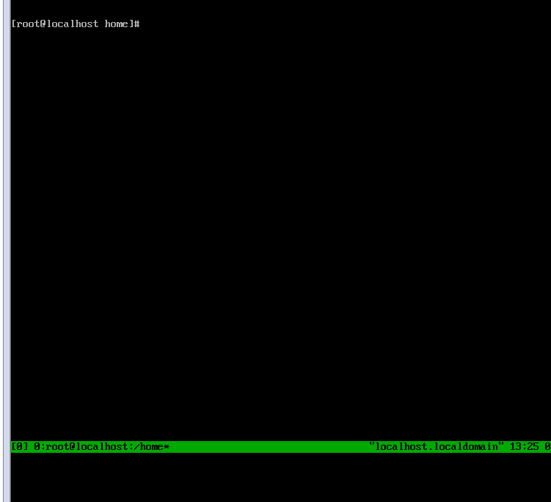

**Loging out**

**While in the tmux session, to logout all you must do is type “logout” in the command line, and it will exit the session.**

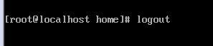

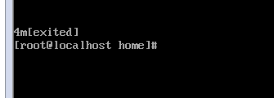

This was done on centOS server, the latest tmux version comes installed on the Ubuntu Server, so no installation is required.